Application just after opened. No active filters. Both axes are at the lowest level:
Calendario (Mes) Calendar (MTHN – month)
Produto (Subclasse) Product (SCLS – subclass)
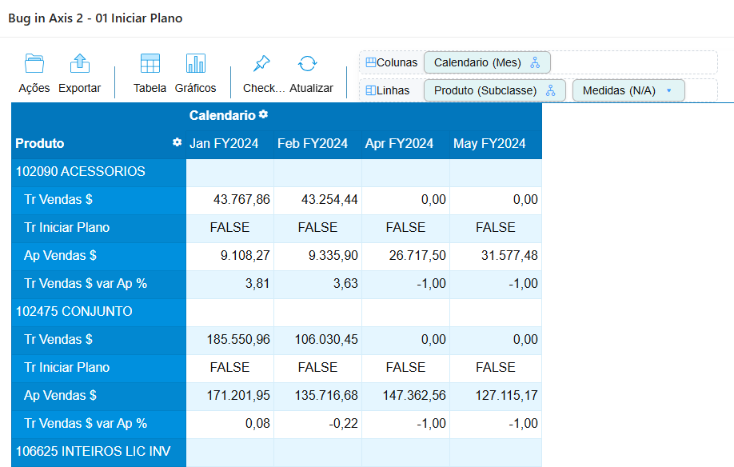
Then we remove the department 1110 (it is the third level of Product Hierachy).
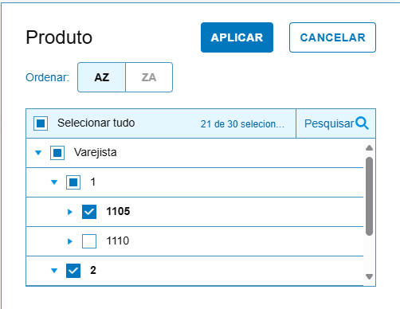
This is what the saved slice looks after this filter is set:
{
"MP_TB01_WS01": {
"rows": [{
"uniqueName": "Produto",
"levelName": "SCLS",
"filter": {
"members": ["Produto.[10].[1].[1105]", "Produto.[10].[2]"]
}
}, {
"uniqueName": "[Measures]"
}
],
"columns": [{
"uniqueName": "Calendario",
"levelName": "MNTH"
}
],
"measures": [{
"uniqueName": "MpWpNSlsR",
"aggregation": "sum",
"grandTotalCaption": "Tr Vendas $",
"format": "retail"
}, {
"uniqueName": "MpWpSeedB",
"aggregation": "ambig",
"grandTotalCaption": "Tr Iniciar Plano (ambig)",
"format": "boolean"
}, {
"uniqueName": "MpLyNSlsR",
"aggregation": "sum",
"grandTotalCaption": "Ap Vendas $",
"format": "retail"
}, {
"uniqueName": "MpWpNSlsRvL",
"aggregation": "reclc",
"grandTotalCaption": "Tr Vendas $ var Ap % (reclc)",
"format": "percent"
}, {
"uniqueName": "MpWpSeedInT",
"aggregation": "ambig",
"grandTotalCaption": "Tr Iniciar Plano Info (ambig)",
"active": false,
"format": "text"
}
]
}

Now I changed the Product Axis to the third level (Department or departamento):
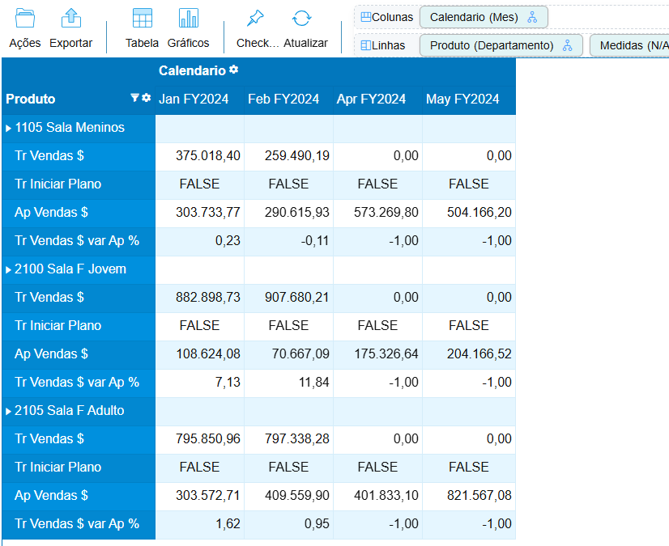
Notice that only departments 1105, 2100 and 2105 are seen in the screen. 1110 is filtered out.
After the hierarchy level change, this is how the slice is being saved:
"MP_TB01_WS01": {
"rows": [{
"uniqueName": "Produto",
"levelName": "DEPT",
"filter": {
"members": ["Produto.[10].[1].[1105]", "Produto.[10].[2]"]
}
}, {
"uniqueName": "[Measures]"
}
],
"columns": [{
"uniqueName": "Calendario",
"levelName": "MNTH"
}
],
"measures": [{
"uniqueName": "MpWpNSlsR",
"aggregation": "sum",
"grandTotalCaption": "Tr Vendas $",
"format": "retail"
}, {
"uniqueName": "MpWpSeedB",
"aggregation": "ambig",
"grandTotalCaption": "Tr Iniciar Plano (ambig)",
"format": "boolean"
}, {
"uniqueName": "MpLyNSlsR",
"aggregation": "sum",
"grandTotalCaption": "Ap Vendas $",
"format": "retail"
}, {
"uniqueName": "MpWpNSlsRvL",
"aggregation": "reclc",
"grandTotalCaption": "Tr Vendas $ var Ap % (reclc)",
"format": "percent"
}, {
"uniqueName": "MpWpSeedInT",
"aggregation": "ambig",
"grandTotalCaption": "Tr Iniciar Plano Info (ambig)",
"active": false,
"format": "text"
}
]
},

Then I quit the application and open Flexmonster again using the slice shown above and this is what is shown on the screen:
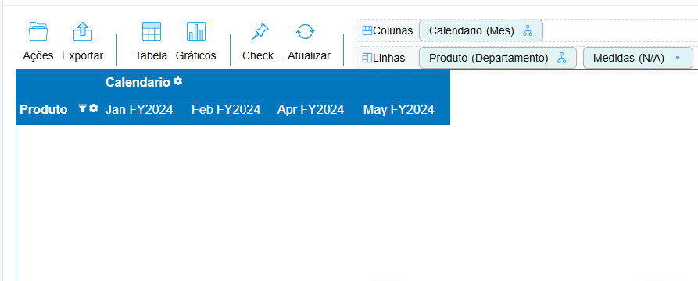
The table below contains all requests and replies that happened since we started opening the report using that slice:
Request type | Request | Reply
handshake
fields
members
members
members
members
members
select
members
members
members
members
members
members
members
select
request

